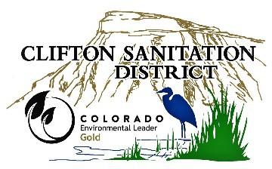
Clifton Sanitation District
3217 D Road
Clifton, CO 81520

Board of Directors Meeting April 8, 2026 at 6:00 P.M.

AGENDA

- Call Regular Meeting to Order Kent Brumback

- Introduction of Guests Kent Brumback
  - Gabe Racz, Esq. – Clark Hill PLC

- Public Comment Period Kent Brumback
NOTE: Three-minutes maximum per speaker with 15 minutes total for public comments

- Meeting Minutes:
Approval of the March 4, 2026 Regular Board Meeting Minutes Action

- Consent Agenda:
Monthly Report Action

- Presentation, Discussion, and Action:
Executive Session Instructions to Negotiators §24-6-402(4)(e), C.R.S Action
- Clifton Fire Protection District Substation
Wage Analysis Discussion/Action
Executive Session Personnel Matters §24-6-402(4)(f), C.R.S Action
- District Manager Review
District Manager Compensation Discussion/Action
Scholarship Program Discussion
Article V Revisions Discussion
Behind the Meter Solar Project Discussion
Transfer Line Project Discussion
Operational Report Discussion

- Financial Report:
Accounts Payable
•EFTs/ACHs | $
•Checks | $
•Credits | $
Total | $

Review Financial Report
and Accounts Payable:
- Unpaid Bills Report
TBD

Approve Financial Report and Accounts Payable Action

- Upcoming meeting dates:
Regular Board Meeting: May 6, 2026 at 6:00 pm

- Adjournment Action

